 | RED Untreated  Neutral Salt Spray testing Industrial steel wire cable  Dulux Powder &Industrial Coating, NZ Ltd Technical & Innovation Laboratory  31B Hillside road, Glenfield, Auckland 0627 | BLACK Original Manufacturer coating | GREEN CorrosionX Heavy Duty
0 hrs.
168 hrs.
336 hrs. | 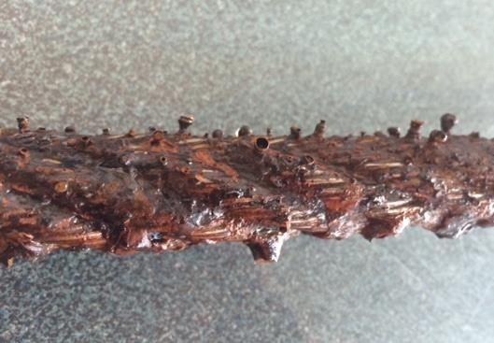 | 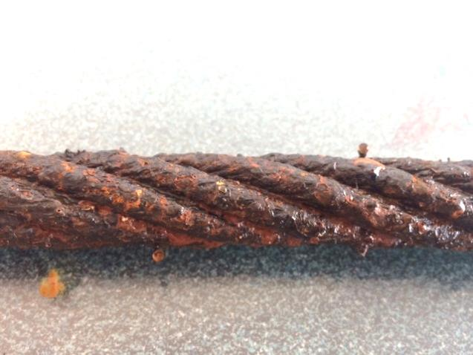 | 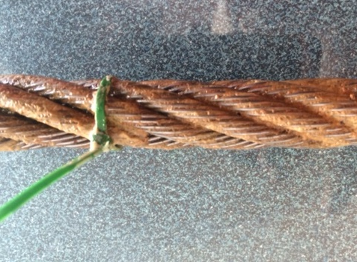
500 hrs. | 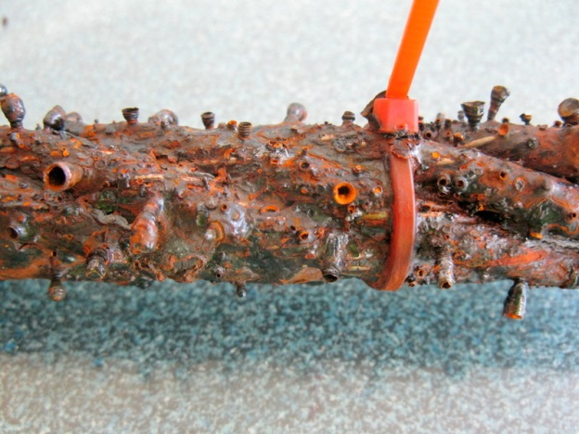 | 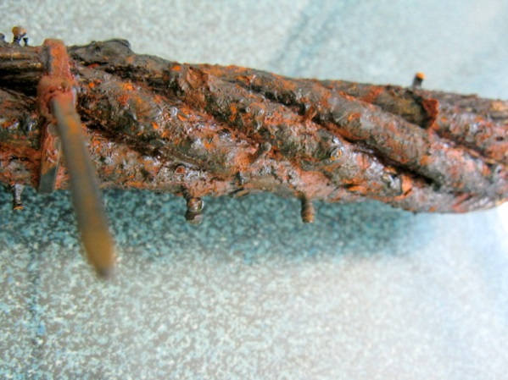 | 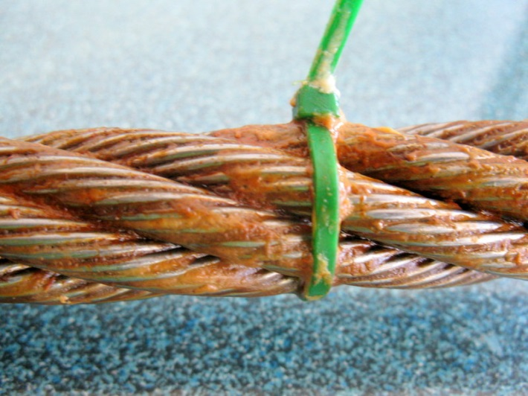
Test Objectives: Three wire samples have been supplied by Corrosion Control Ltd for neutral spray testing. The samples are identified by cable ties as below:
- RED cable tie is the reference sample.
- GREEN cable tie is coated with CorrosionX Heavy Duty.
- BLACK cable tie is unspecified imported wire sample.
Test Method:
1. The initial photos of the wire samples is taken before commencing the Neutral salt spray test.
2. Test Method: AS 2331.3.1: Neutral Salt Spray Test
3. The samples are placed in Neutral salt spray cabinet making sue wire samples are not touching each other.
4. The samples are inspected weekly basis and photos taken to capture the onset of corrosion
5. Report.

